****

**END OF TERM ONE EXAMINATIONS 2023**

**TOP CLASS**

**SOCIAL DEVELOPMENT**

NAME\_\_\_\_\_\_\_\_\_\_\_\_\_\_\_\_\_\_\_\_\_\_\_\_\_\_\_\_\_\_\_

1. **Read and draw**.

|  |  |  |
| --- | --- | --- |
| baby | mother | sister |
|  |  |  |
| father | brother |  |
|  |  |  |

1. **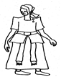Name the picture**.

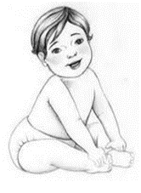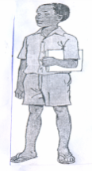

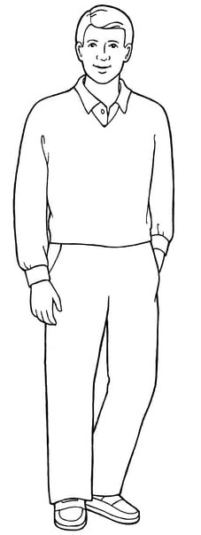

1. **Match pictures to words**.

jug

tree

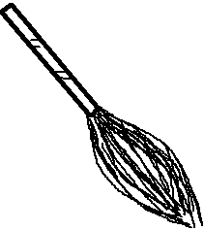

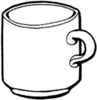

tin

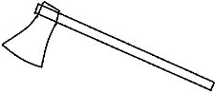

broom

cup

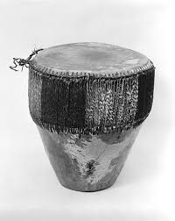

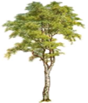

axe

drum

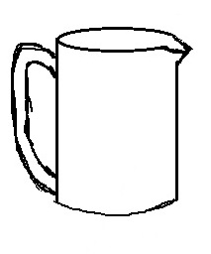

1. **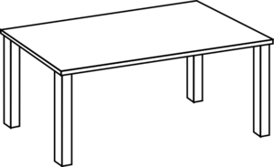Name the pictures**.

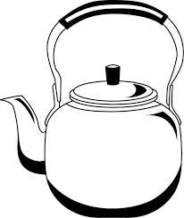

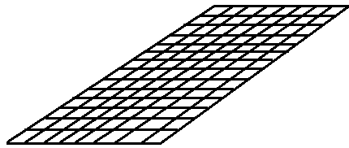

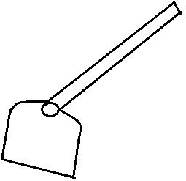

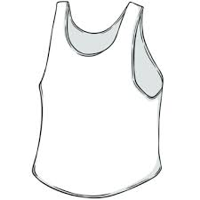

1. **Circle the right word**.

|  |  |  |
| --- | --- | --- |
| D:\my pics\img 1 (76).jpg | tap | yam |
|  | girl | fish |
|  | water | wall |
| C:\Users\Raayat computer\AppData\Local\Microsoft\Windows\INetCache\Content.Word\IMG_2859.PNG | water | rice |
| https://encrypted-tbn1.gstatic.com/images?q=tbn:ANd9GcQhhFCVck52xUt7iZ4wD3napYhhp9Rn8957UXchsIzYDU7kz8lN0HNhEw | apple | tree |

1. **Read and draw**.

|  |  |  |  |
| --- | --- | --- | --- |
| chalk | book | ball | pen |
|  |  |  |  |
| bag | bus | doll | chair |
|  |  |  |  |

1. **Name the pictures**.

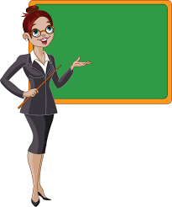

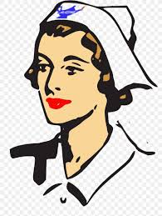

nurse

policeman

teacher

cook

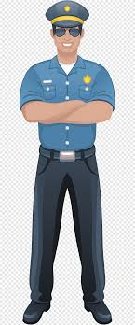

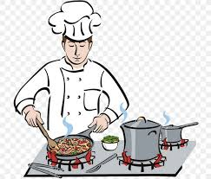

1. **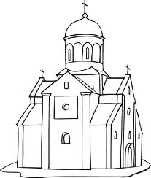Fill in the missing**.

Ch\_\_\_ \_\_\_\_ch

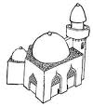

mos \_\_\_\_ue

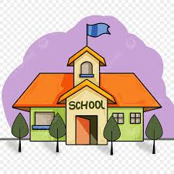

sch\_\_\_ \_\_\_\_ \_\_\_\_

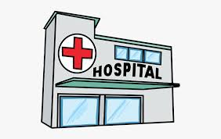

hosp \_\_\_\_ \_\_\_\_al

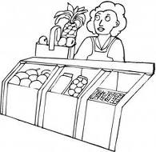

mar\_\_\_ \_\_\_\_t

1. **Write the picture number**.

****

1

5

2





3

4

school \_\_\_\_\_\_\_\_\_\_\_\_\_ mosque\_\_\_\_\_\_\_\_\_\_ hospital \_\_\_\_\_\_\_\_

church \_\_\_\_\_\_\_\_\_\_ market \_\_\_\_\_\_\_\_\_

1. **Read and draw**.

|  |  |  |
| --- | --- | --- |
| cup | plate | broom |
|  |  |  |
| mat | kettle | basket |
|  |  |  |